#SKILL - 16 ⎝ API Documentation for Full-Stack Student CRUD Application using Swagger
ID : 2400031595
Name : Rameshkumarkandula

STEP 1: CREATE PROJECT FOLDER STEP 2: In the STS
File → New → Spring Starter Project ( create the package and class)
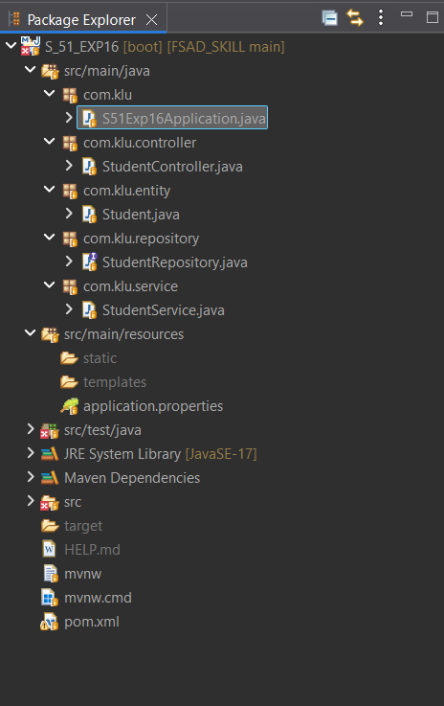
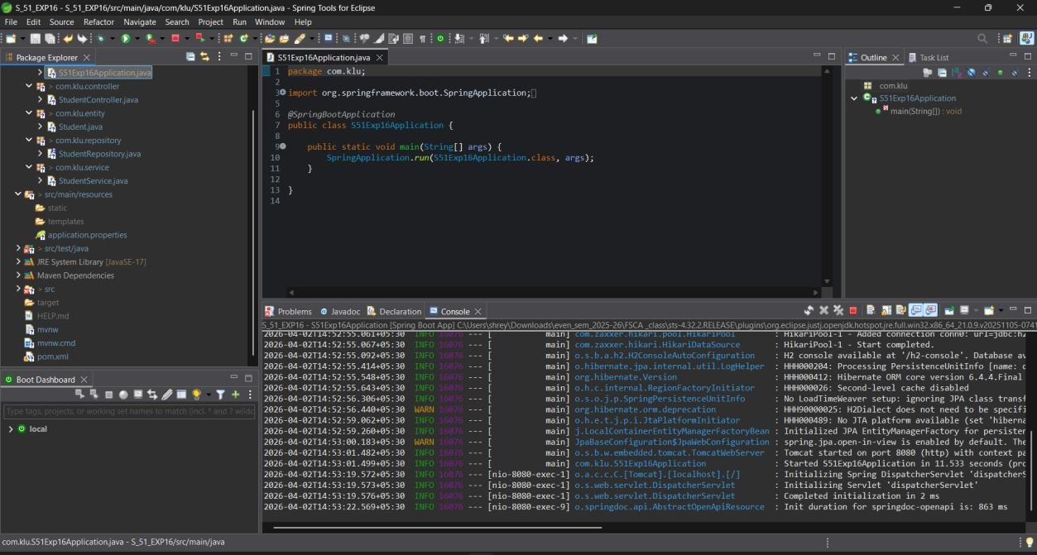

Ouput:
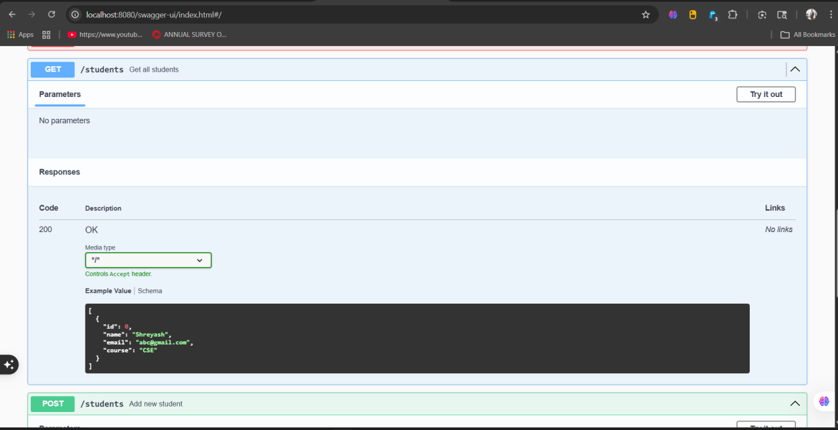

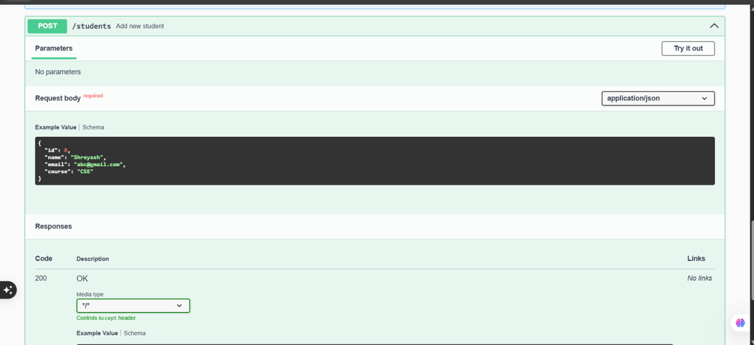

PUSH TO GIT HUB
